Azure pipeline:

* Azure pipelines automatically build and test code projects to make them available to others.
* When we develop a software, it needs to be build.so there are some steps to follow.
* We pick up a piece of code we run some tests on the top of the code.
* If any changes required again, we built the code and again we test it. if it is ready, we deploy and deliver it to the end customer.
* Instead of doing all this separately the azure pipeline will do it once under the umbrella.
* There are some features they are:
* Platform and language independent.
* Freedom to work with containers.
* Deployment to other cloud vendors.
* Support for open source.
* We can run in ant platform like windows, Linux, mac.
* We can build an application using different programming languages.
* We can store the source code in container and run anywhere.
* We can move our application to other cloud vendors like AWS, GCP if we are working in azure.

ARM templates:

* ARM template is a block of code that defines the infrastructure and configuration for your project.
* Components of ARM templates.
* Parameters
* Functions
* Variables
* Resources
* If we create any resource the template will be generate automatically.

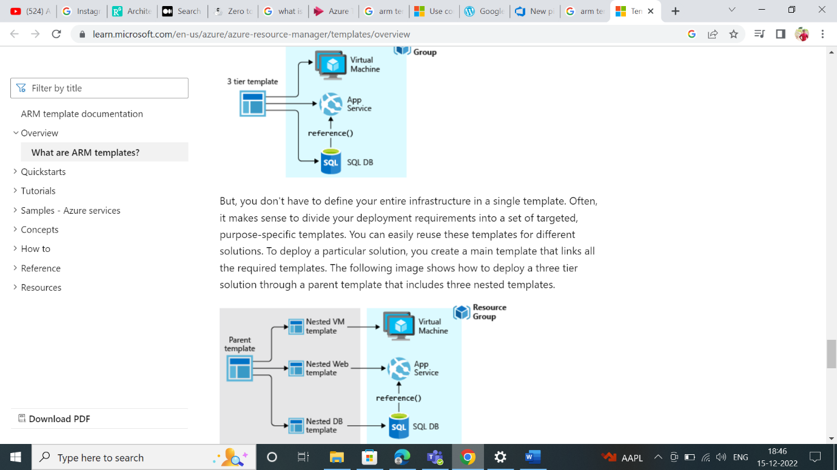

* If we create any resource in azure portal and if we explore template, we can the code which is in JSON format.

